**Ravi Tomar**

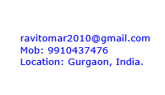 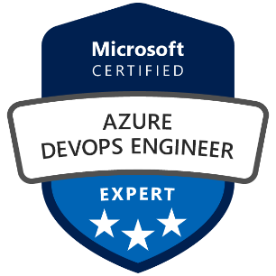 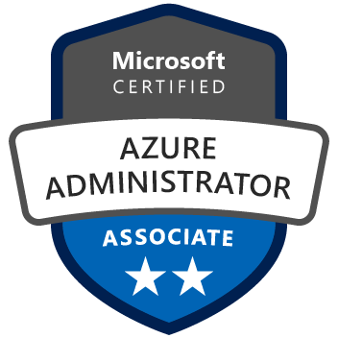

## SUMMARY:

## Microsoft Certified Azure AWS,GCP DevOPS Engineer with 8 years of Professional experience in working on DevSecOPS (Azure, AWS, GCP,GIT, TFS ,Jenkins, terraform, Ansible, docker,Gremlin), IIS ,apache, Windows and Linux/ubuntu server . Quest to work in an environment that enables me to enrich my knowledge by working with the existing and emerging technologies.

**SOFTWARE EXPERTISE:**

|  |  |
| --- | --- |
| **Infrastructure** | Azure  AWS  GCP  ON Premises |
| **Script Language** | PowerShell  Shell/bash  Python  Batch script |
| **Certification** | Microsoft Certified Azure Associate  Microsoft Certified azure DevOps Expert  LinkedIn AWS certified  LinkedIn / Coursea GCP Certified  SharePoint Server 2013 administration |
| **Tools** | SonarQube  Azure DevOPS pipeline  Puma Scan  TFS & GIT  Nexus,  Jenkins,  ZAP OWASAP,  Docker  Kubernetes(k8)  VSTS  Ansible  Terraform(IAAC)  RabbitMQ  Gremlin  Chaos Engineering |
| **Operating System** | Windows Server 2012/2008,  Linux REDHAT 7  Ubuntu |
| **Database** | SQL Server 2008,2012,2014, Redis ,Redshift, Hadoop |
| **Domain** | Education, Banking, Insurance ,Telecom and Automation service industry, Retail |

## EMPLOYMENT: (Total: 8 years)

## Presently Working: [NAGARRO SOFTWARE PRIVATE LIMITED](https://www.tofler.in/nagarro-software-private-limited/company/U72900DL1996PTC075453)

## Designation: Staff Engineer (DevOPS)

**Responsibilities:**

1. Azure Devops CICD Pipeline Creation.
2. AKS cluster Management and development
3. GCP VM Server automation
4. Jenkins to automate the AWS CICD Process
5. Infrastructure automation using Terraform.
6. Ansible for server configuration.
7. Docker and Kubernetes for containerised Applications.
8. Grafana/ELK for monitoring and Logging purpose.
9. BitBucket/GIT and VSTS for Source Code Management
10. Ldap integration
11. Sonar integration with lambda pipeline.
12. Jenkins for automate tasks.

## Worked with: Intersoft DataLabs Pvt Ltd.

## Designation: Sr. System Analyst ( DevOPS )

## Period: May 2020 to Nov 2020

**Responsibilities:**

1. AWS IAM process automation
2. S3 bucket policy automation
3. Redshift day to day unload load data migration automation .
4. Import export to S3 data automation.
5. NIFI CICD using terraform.
6. AWS infrastructure automation using Terraform.
7. Ansible for server configuration.
8. Grafana for monitoring purpose .
9. Azure devops pipeline for CICD of. Net application.
10. CodeCommit for repository and git for version controlling.
11. Hadoop, redshift, ETL process automation
12. Ldap integration
13. Sonar integration with lambda pipeline.

## Worked with : MERCER CONSULTING

## Designation: Module lead ( DevOPS )

## Period: Feb 2018 to April 2020

**Responsibilities:**

1. On board all Mercer application using CICD via discussion application required with software develeopers.
2. Creates Jenkins script as per their deployment requirements.
3. ETL process Automation
4. Use ZAP for Dynamic Scanning
5. Creates CI using VSTS and TFS via creating Build and release.
6. Creates Agent on servers to run as service for build/Release
7. Configure windows server for deployment using MS Deploy and visual studio
8. Configure rules and authentication on IIS sites /application.
9. Docker for war file deployment on container.
10. Kubernetes(k8) for container Orcatestration.
11. Ansible for configuration management and terraform for infrastructure deployment.
12. Zap OWASAP for Dynamic scanning and sonar for static scanning.
13. Nexus for Artifactory management.
14. Worked on TFS and Azure devops CICD pipeline for build and release of Net/.Net Core,Java and Node.js projects.

## Worked with: Cognizant India Pvt. Ltd. Noida

## Designation: Technical Lead

## Skill: Azure DEVOPS and AWS INFRA

**Period: Sept 2016 to Feb 2018**

## Responsibilities:

.

* GIT and TFS for CICD.
* Azure Devops Pipeline creation for build and release.
* Docker for running application on Containers and mange it
* Monitoring of alerts on SharePoint Server. Monitoring health analyser and resolving issues if any.
* .Net application hosting, maintenance and Troubleshooting.
* IIS Sites rule configuration for CICD.
* Application Build creation using TFS and GIT
* Release Creation using TFS
* Worked on AZURE Devops platform
* AWS EC2 instance support and administration
* Azure Resource group and subscription setup
* Site page customisation and branding

## Worked with: Teamware Solutions

## Designation: System Administration

## Period: Sept 2015 to Sept 2016

## Responsibilities:

## SharePoint Site managing and handled permission issues.

## Responsible for site administration.

## Creating/updating sites, managing permissions.

* Lotus domino server administration troubleshooting and monitoring.
* O 365 Licensing assigning and troubleshoot client end issues.
* Mail flow monitoring and troubleshooting.
* Working on BMC YODA ticketing tool to resolve O365, SharePoint and Lotus Notes related issues.
* Office 365 Administration.
* Migration from lotus notes to office 365.

**Worked with: Horiba India Pvt. Ltd. Delhi**

**Designation: IT Support Engineer**

**Period**: Feb 2013 to July 2015

**Responsibilities**:

* Installing, configuring, maintaining, upgrading and managing a SharePoint Server or a Farm.
* Configuring service applications.
* Lotus Domino server administration monitoring and troubleshooting.
* Office 365 users License Assignment
* Mail flow routing troubleshooting in O365.
* Training and supporting the business users in their day to day involvement in SharePoint/O365. For instance uploading a document, starting an approval workflow etc.
* OWA connectivity troubleshooting using Microsoft RCA Tool.
* Server 2008 R2 Enterprise installation and configuration (Domain/Thin Client/ERP/Mail Server/File Server).
* VMware VSphere Client windows server monitoring.

**TECHNICAL SKILLS:**

* Azure and AWS Platform knowledge
* Knowledge in Docker,Kubernetes , GIT ,Jenkins, TFS,IIS
* Knowledge in Microsoft SharePoint 2010/2013/2016.
* Knowledge of Active directory ,SQL, DNS

**PROFESSIONAL QUALIFICATIONS:**

* + **B.Tech. in (Computer Science)** from Dronacharya college of Engineering, Gr.Noida , UPTU with **75.35 %**.

## ACADEMIC QUALIFICATIONS:

* + Senior Secondary Education from CBSE Board with **75%.**
  + Higher Secondary Education from CBSE Board with **58%.**

**PERSONAL PROFILE:**

Address (Present) : Q-563 Jalvayu Vihar sector 30 Gurgaon

D.O.B : 18 December 1989

Permanent. Address : 91, Ram Nagar Ward no 13 G.T Road Dadri Gr.Noida.

Telephone : 9910437476/8178731912

Alternate Id : ravitomar2010@gmail.com